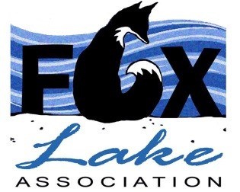

FOX LAKE ASSOCIATION ANNUAL GENERAL MEETING

SATURDAY JULY 8, 2023
10:00 a.m.

504 EAST FOX LAKE ROAD
Home of David Blanchard and Sharon Lillico

AGENDA

- Welcome
- Adoption of the meeting agenda
- Dialogue with Camp Winnebago representative
- Acceptance of the Minutes of the 2022 AGM
- Matters arising from the Minutes of the 2022 AGM
- Annual report of the President of the Association
- Financial report from the Treasurer and acceptance of the financial statements of the corporation
- Election of a Director to the FLA Board of Directors
- Report from the Membership Officer
- Report from the Lake Steward
- Update from the Regatta Coordinator
- Update on the Corn Roast/Fall Fair
- Presentation on Fox Lake History Project
- Date and location of the 2024 AGM
- Adjournment

SOCIAL:
Everyone is welcome to stay and socialize following the meeting.
Finger foods and soft drinks will be available.

